Architecture Overview
StarUM Platform – Current State Architecture

Index
- GKE Platform
- Database
- Java
- DevOps & Terraform
- Network

1. GKE Platform
The StarUM application platform runs on GKE Autopilot with two regional clusters across us-central1 (Primary) and us-east4 (Secondary). Both clusters host the same microservices, rely on Horizontal Pod Autoscaling (HPA), and are fully managed by Google — covering infrastructure, node provisioning, and upgrades — with limited workload-level control available to the platform team.
Application deployments follow a rolling deployment strategy. Secrets and configurations are managed via Kubernetes Secrets and ConfigMaps. Observability is provided through Dynatrace and Splunk, with perimeter protection enforced by Cloud Armor.
Traffic is managed through two load balancing layers. Layer 7 — GCP HTTP(S) Load Balancers integrated with GKE services, using BackendConfig and NEG (Network Endpoint Group) for direct LB-to-pod health checks, with SSL/TLS 1.2 policies for secure communication. Layer 4 — an Internal TCP/UDP Load Balancer handles service-to-service traffic between UI and backend ports.
The clusters follow an Active/Passive DR model — the primary region (us-central1) handles all live traffic, while the secondary (us-east4) acts as a standby DR environment. Failover is performed manually by updating the load balancer/backend configuration.

GKE Cluster Overview
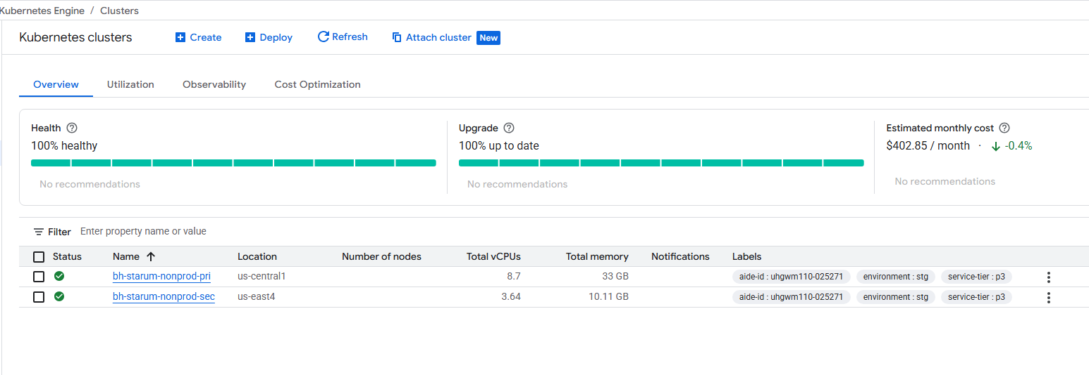
No Fleet Enrollment
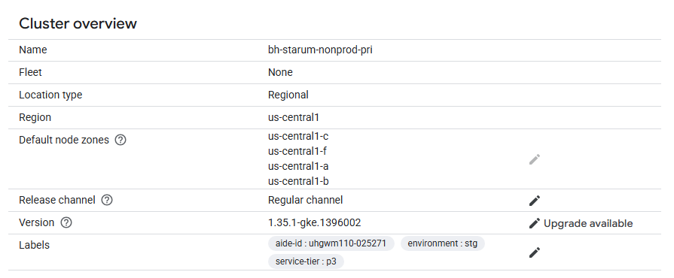
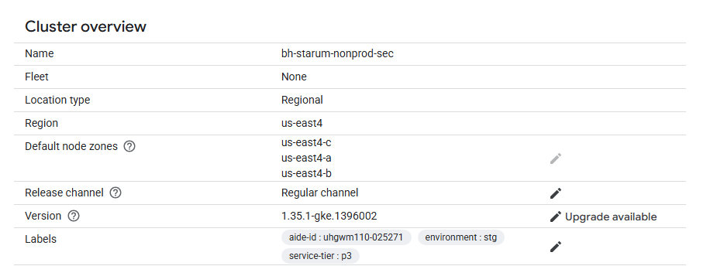

Workloads – Rolling Deployment
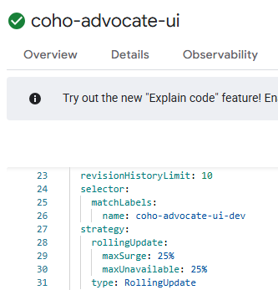
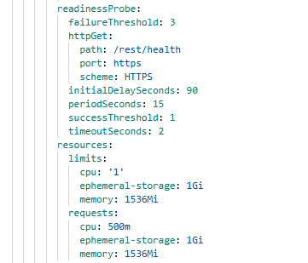

Ingress Resources:

K8s Secrets & ConfigMap:
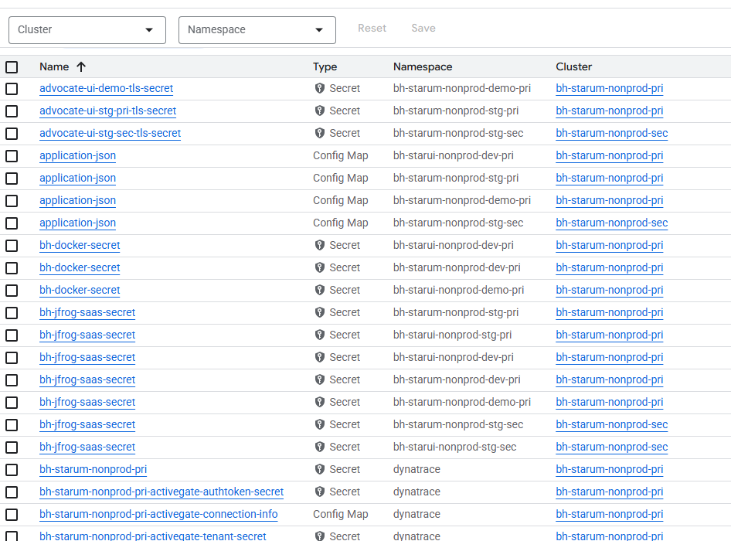

Primary:
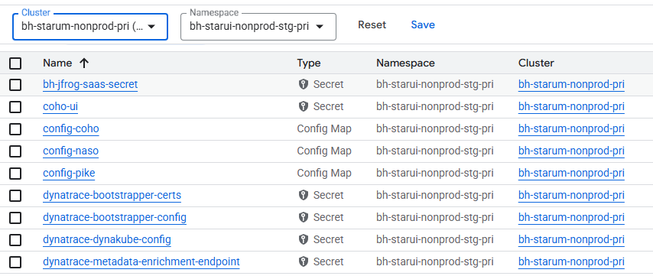
Secondary:
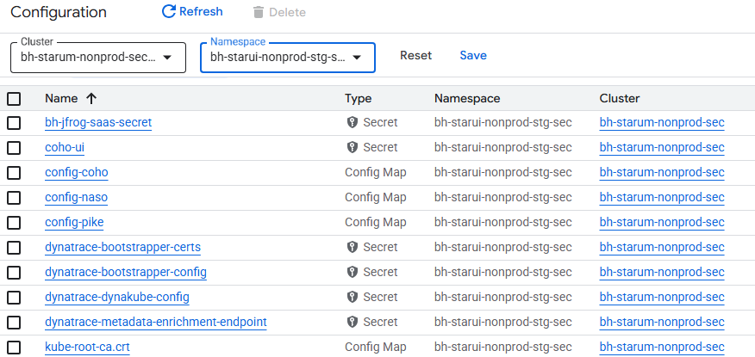

2. Database
The current database architecture is built around a single writable primary instance, with one or more read replicas configured primarily for read scalability rather than high availability. All write operations are routed to the primary database, making it a central dependency for application availability.
Failover to a replica is entirely manual, requiring operational intervention to promote a replica during a primary or regional failure. No automated failover or health-based promotion mechanisms are in place.
The database environment has not undergone formal failover drills, leaving recovery timelines, database availability, and application reconnection behavior unvalidated.
There is no strategy for migrating the on-premises database to GCP. A previous migration attempt was unsuccessful and was rolled back, with no recorded root cause analysis to inform future migration efforts.
Backup mechanisms are assumed to be configured; however, backup retention policies, restore procedures, and cross region recovery have not been validated through testing. Additionally, multiple upstream systems write directly to the database without centralized write control.

Cloud SQL instance overview showing a single writable MySQL 8.0 primary deployed in a single zone with High Availability disabled,

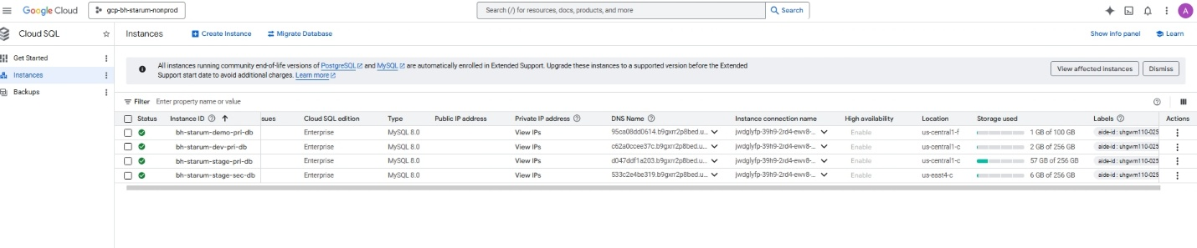

Absence of read replicas the database is deployed as a single writable primary,
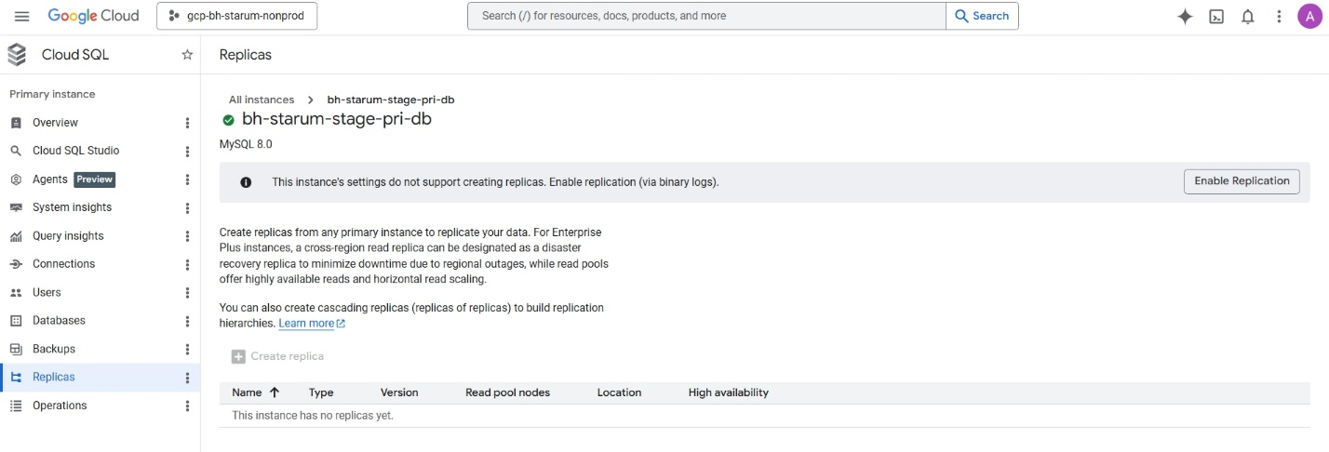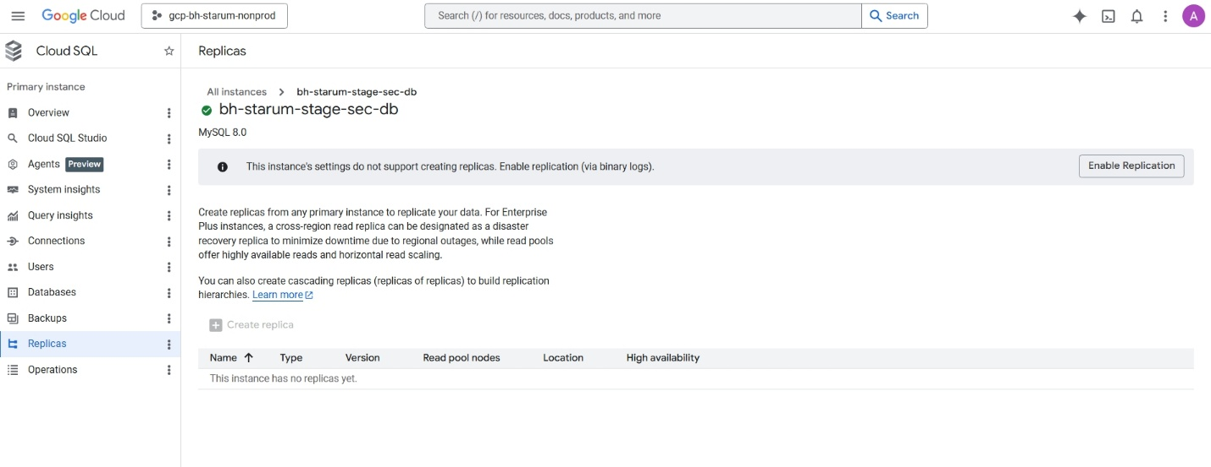
Automated backups are enabled with a daily schedule,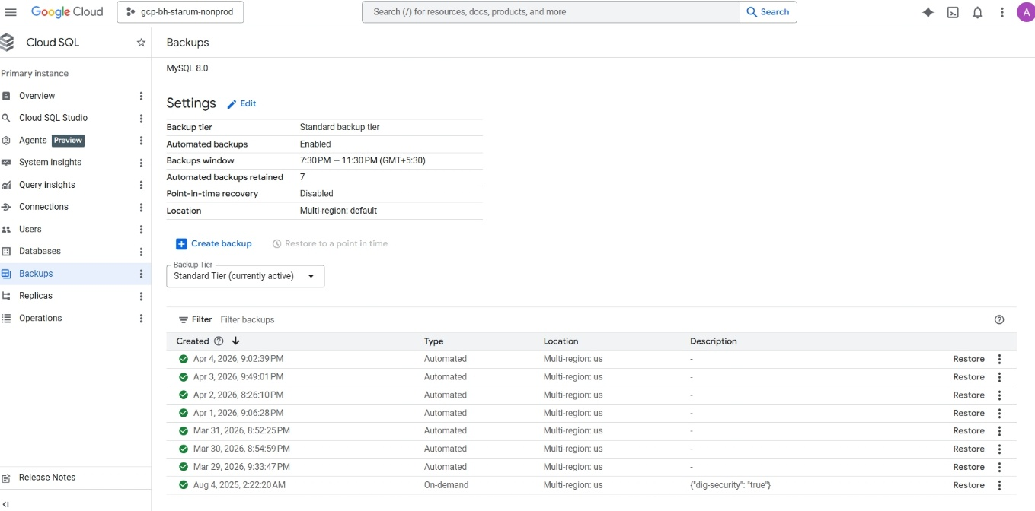
Cloud SQL security configuration showing encryption at rest using Google-managed keys and support for SSL/TLS encrypted connections. No custom or customer-managed encryption keys are configured.
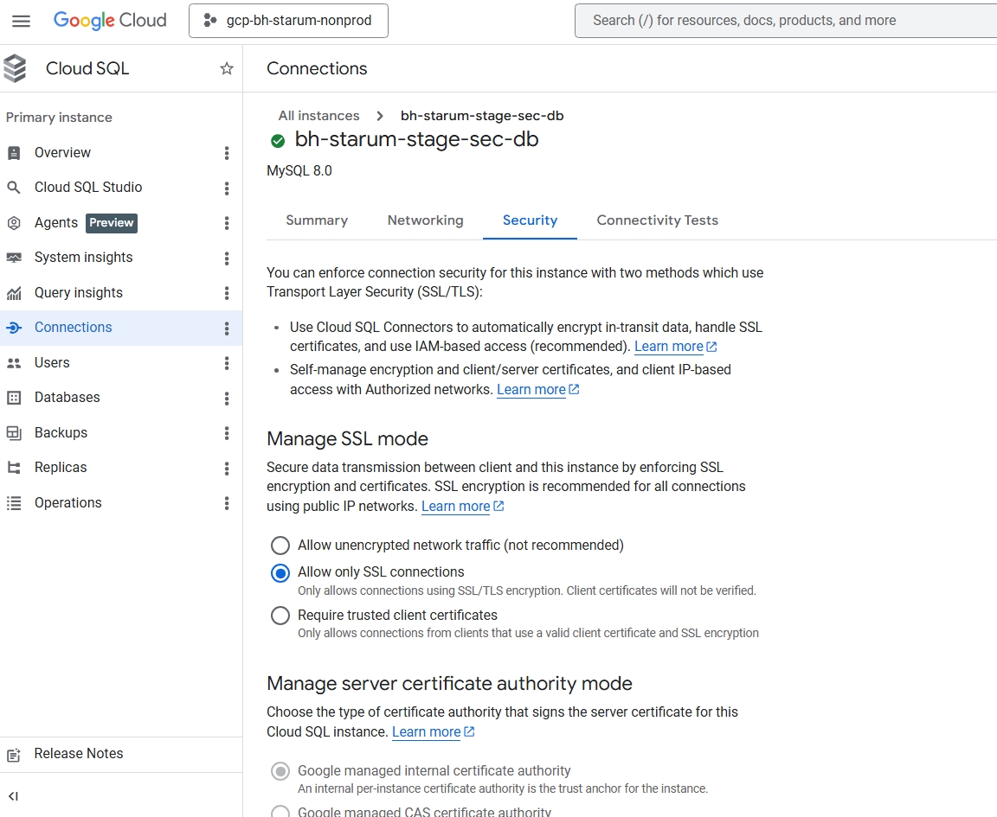
Cloud SQL maintenance configuration showing no fixed maintenance window, indicating that platform-initiated updates may occur at any time.
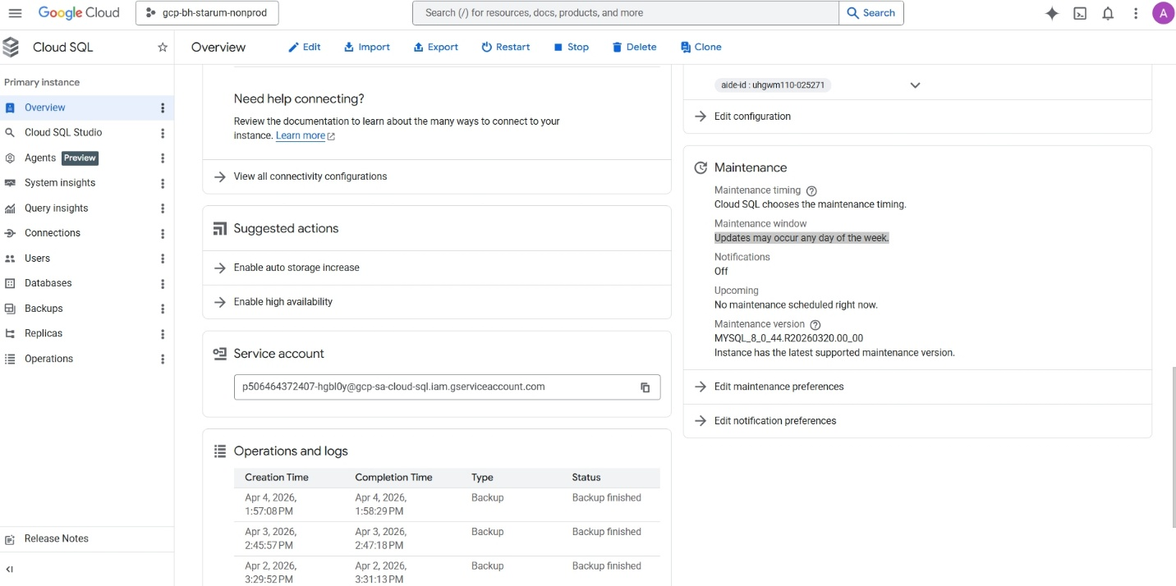

3. Java
The Java application layer has multiple structural risks spanning runtime, security, and operability. A mixed JUnit 4/5 testing setup with PowerMock limits compatibility with Java 21. JVM heap is capped at 1GB, insufficient for Spring Boot 3 workloads with Hibernate and Kafka. Authentication is tightly coupled to Ping Federate, creating a single point of failure. Database connectivity relies on a small, static HikariCP pool that constrains GKE autoscaling. Secrets are managed via Jasypt instead of GCP Secret Manager. Kafka with Avro depends heavily on Schema Registry availability, observability relies on synchronous Splunk logging, distributed tracing is absent, and CI builds risk instability due to aggressive Surefire forking.

4. DevOps & Terraform

4.1 Terraform Usage Without Clear Governance
Terraform is used for infrastructure provisioning across the StarUM GCP environment, but there is no confirmed module strategy, no versioned module libraries, and no documented state management approach (remote backend, locking, or per-environment isolation). Without standardized modules and state governance, infrastructure may be provisioned inconsistently across dev, test, and production environments. This creates configuration drift that can cause unpredictable failures during recovery or scaling events.

4.2 CI/CD Pipeline Resilience Gaps
GitHub Actions is the standard CI/CD tool for application builds and deployments. Version control follows trunk-based development. However, there is no separation between infrastructure and application pipelines, no approval gates, no policy-as-code validation, and no infrastructure drift detection. Pipelines are optimized for deployment speed, not deployment safety. Faulty infrastructure or application changes can reach production without any containment or validation checkpoint.

4.3 Rolling Deployment Without Release Isolation
Current deployment uses rolling updates on GKE Autopilot clusters. Blue-Green and Canary deployment strategies are identified as future goals but are not implemented. There is no automated rollback, no release validation gates, and no progressive traffic shifting. Rolling deployments cannot isolate faulty releases. A bad deployment impacts all users simultaneously. Zero-downtime deployment remains aspirational and is not achieved in the current state.

4.4 Missing Resource Labeling & Tagging Standards
No resource labeling or tagging strategy is defined. Cost allocation labels, environment identifiers (dev/test/prod), ownership markers, and service-level tags are not applied to GCP resources such as GKE clusters, Cloud SQL instances, or networking components. Absence of labels leads to reduced visibility, poor cost tracing, weak operational ownership, and slower incident response. Policy-driven governance and automated reporting cannot be implemented without a labeling foundation.

4.5 Weak Application-Level Resilience Ownership
Application teams rely on platform monitoring (Splunk HEC) and log-based alerting for failure handling. Preventive resilience patterns such as retries, circuit breakers, bulkheads, and timeouts are not embedded in application code. SRE involvement is limited to autoscaling work in progress. Reliability is treated as a reactive operational task, not a shared discipline. There are no error budgets, no SLO/SLA ownership by development teams, and no joint Dev-Ops-SRE accountability. Faults propagate through the system during dependency failures, causing cascading incidents.
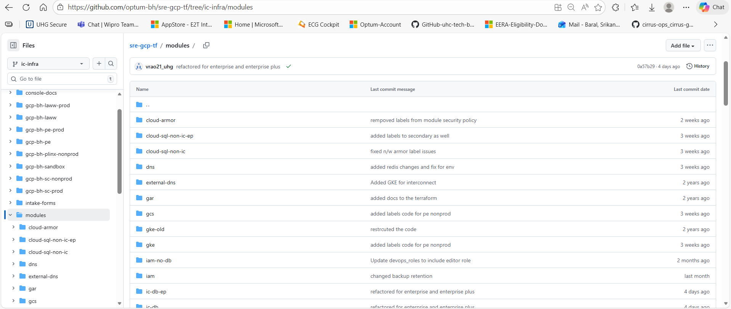
No centralized module repo
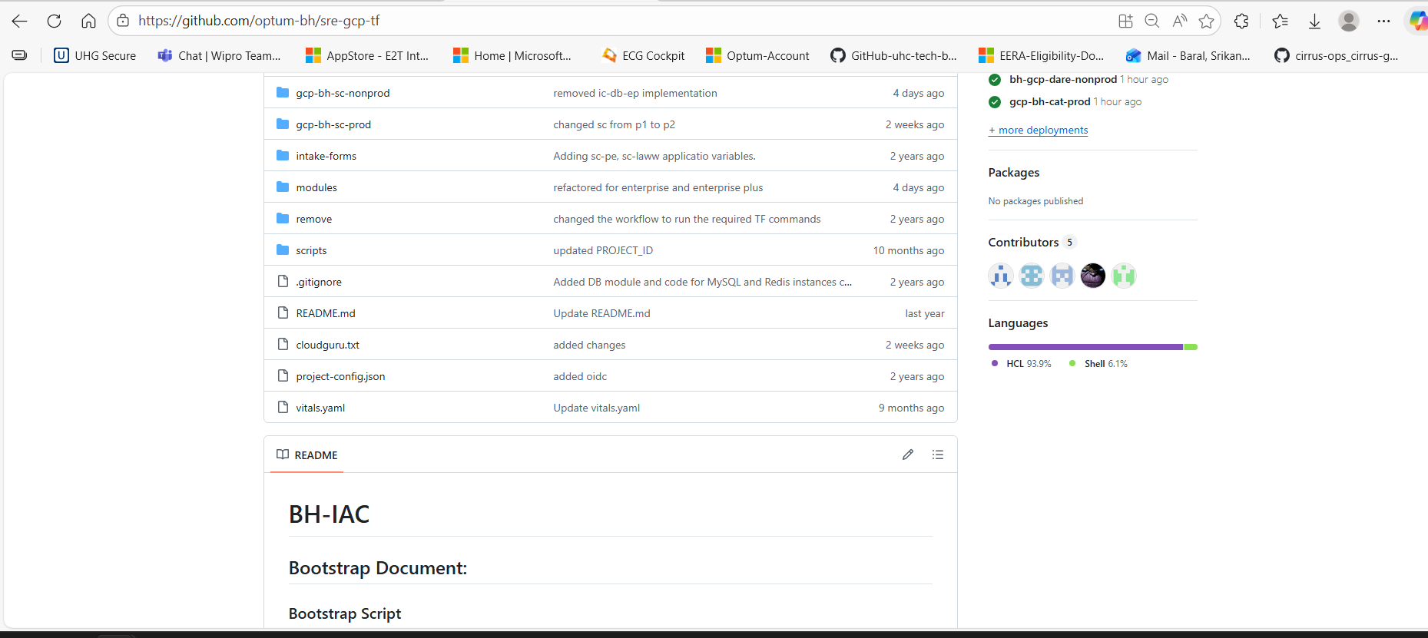
No remote backend config and No state locking
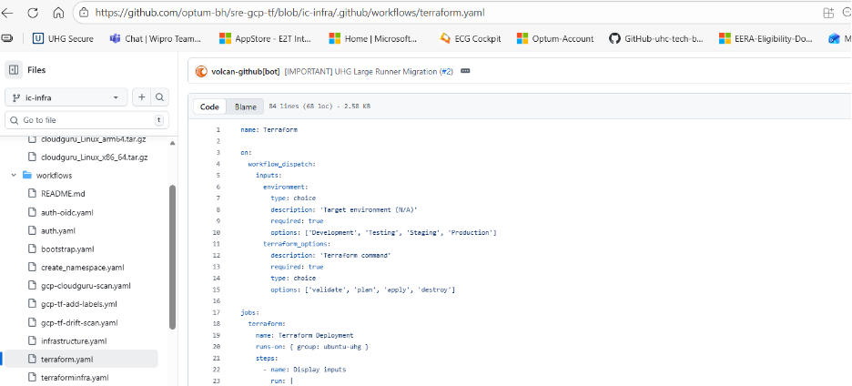
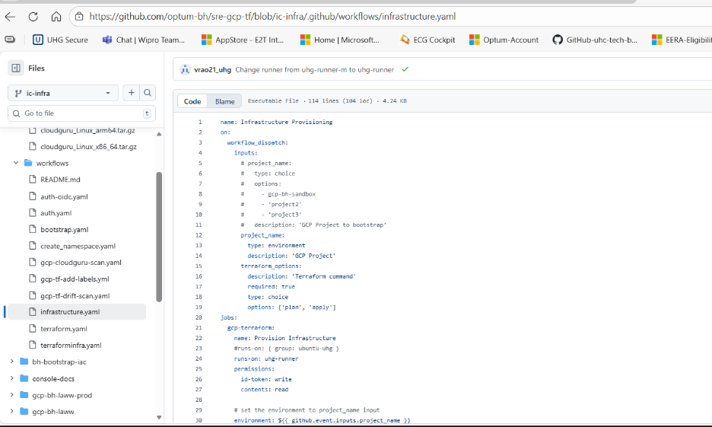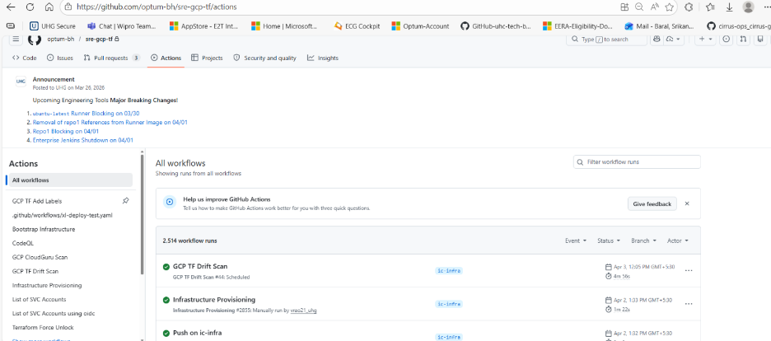
its unmanaged And manual trigger
No approval gate
No policy validation, direct execution of terraform
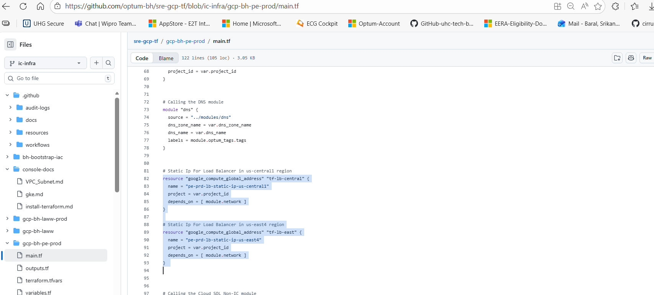
Missing labeling and tagging

5. Network
The application is deployed on Google Kubernetes Engine (GKE) across multiple regions, following an Active/Passive architecture where the primary region handles all production traffic and the secondary region acts as a standby Disaster Recovery environment. The application is exposed via GCP HTTP(S) Load Balancers integrated with GKE services, with backend services configured to point to GKE workloads. The failover process is manual, requiring either an update to the load balancer backend configuration or a traffic redirection to the secondary region.
DNS resolution is managed through Cloud DNS, mapping application domains to load balancer frontend IPs using static IP addresses configured via DNS records. Cloud NAT is configured to facilitate outbound internet access from private workloads.
From a security standpoint, Cloud Armor (WAF) policies are applied for selected applications, SSL policies with TLS 1.2 are enforced for secure communication, and firewall rules are configured at the VPC level to allow required application ports (HTTP, HTTPS, and custom ports), though wide port ranges and IP ranges have been observed.
